
SCHOOL OF COMPUTING AND ENGINEERING SCIENCES (SCES)
BACHELOR OF SCIENCE IN ELECTRICAL AND ELECTRONICS
ENGINEERING (BSEEE)
PLC AND INDUSTRIAL AUTOMATION
TECHNICAL LAB REPORT:

OPEN PLC AND INDUSTRIAL AUTOMATION LAB REPORT

BY
Edward Mwongela
142092

Lecturer: Omae Malack Oteri
2nd Feb 2025

Table of Contents
List of figures 3
Abstract 5
Objectives 5
Theory 6
Programmable Logic Controller 6
PLC Components 6
PLC Timers 6
PLC Programming Languages 7
TinkerCAD for Arduino Simulations 7
Materials & Components used 8
Methodology/Procedure 11
Results and discussion 41
Conclusions and recommendations 53
Key Findings 53
Key Learnings 53
Real-Life Applications 54
Possible Errors and Challenges 54
Recommendations for Future Work 54
References 56

List of figures
Figure 1. setup_1 12
Figure 2. setup_2 12
Figure 3. setup_3 12
Figure 4. setup_4 13
Figure 5. setup_5 13
Figure 6. Conveyor system 14
Figure 7. all gates implementation 15
Figure 8. analoginout 16
Figure 9. and gate implementation 17
Figure 10. buttonMotor control 18
Figure 11. down counter 20
Figure 12. Fire alarm 22
Figure 13. gate control system 23
Figure 14. gate with serial input 24
Figure 15. greenhouse sensors 25
Figure 16. IR with LED 26
Figure 17. latch implementation 26
Figure 18. latching with an IR 28
Figure 19. LED blink 28
Figure 20. NAND Gate implementation 29
Figure 21. not gate implementation 30
Figure 22. OR NAND gate 31
Figure 23. OR Gate 32
Figure 24. PTWIA implementation 33
Figure 25. pulse function 34
Figure 26. security SR 34
Figure 27. simple car parking system 35
Figure 28. toggle flipflop 36
Figure 29. two in rgb motor 37
Figure 30. xnor gate 38
Figure 31. XOR gate implementation 39
Figure 32. conveyor belt result 1 41
Figure 33. conveyor belt result 2 41
Figure 34. all gates result 42
Figure 35. and gate result 42
Figure 36. buttonMotor control result 43
Figure 37. down counter result 43
Figure 38. gate control system result 44
Figure 39. gate with serial input result 45
Figure 40. greenhouse sensor result 45
Figure 41.IR with LED 45
Figure 42. latch results 46
Figure 43. latching with IR results 46
Figure 44.LED blink results 47
Figure 45. NAND gate implementation 47
Figure 46. NOT gate result 47
Figure 47. OR NAND gate result 48
Figure 48. OR gate results 48
Figure 49. PTWIA result 49
Figure 50. pulse function result 49
Figure 51. Security SR result 50
Figure 52. simple car parking system 50
Figure 53. toggle flipflop results 50
Figure 54. two in rgb motor results 51
Figure 55. XNOR gate results 51
Figure 56. XOR gate results 52

Abstract

This lab report explores the practical application of Programmable Logic Controllers (PLCs) in industrial automation using OpenPLC software and Arduino. The experiments focused on implementing basic logic functions, motor control, sensor integration, and analog signal processing. The results demonstrated the successful application of PLC programming in various automation scenarios, including conveyor systems, motor control, and environmental monitoring. The report concludes with key learnings, real-life applications, and recommendations for future work in advanced PLC systems and IoT integration.

Objectives
The primary objective of this experiment is to apply theoretical concepts of PLC programming in a practical, hands-on environment using OpenPLC software and Arduino under the guidance of Dr. Malack Oteri. The specific objectives include:
- Designing and developing PLC-based automation systems using OpenPLC and Arduino.
- Implementing basic PLC logic functions (AND, OR, NOT, timers, counters) in real-world automation scenarios.
- Testing and validating PLC programs using ladder logic and structured text.
- Comparing virtual simulations in TinkerCAD with physical Arduino setups.
- Troubleshooting errors in PLC programming and hardware integration.

Theory

Programmable Logic Controller
A Programmable Logic Controller (PLC) is an industrial digital computer designed for automation and control of manufacturing processes[1]. PLCs are used in industries such as manufacturing, robotics, energy management, and transportation due to their reliability, programmability, and ability to handle multiple inputs and outputs​.
PLCs function by receiving input signals from sensors, processing them according to a predefined logic program, and then sending output signals to actuators or other devices to perform control actions. These devices offer advantages such as durability in harsh environments, ease of programming, and high-speed execution of logic functions​.

PLC Components
A PLC system consists of several key hardware and software components that interact to control industrial processes efficiently:
- Power Supply – Provides electrical power to the PLC system.
- Central Processing Unit (CPU) – The "brain" of the PLC, which executes control logic, processes input signals, and determines output responses.
- Memory – Stores user-defined programs, system data, and variables for execution.
- Input and Output Modules (I/O) – Interfaces that connect sensors, actuators, and external devices to the PLC.
- Communication Interfaces – Facilitate data exchange between PLCs and external systems, such as Human-Machine Interfaces (HMI) or other PLCs​.

PLC Timers
PLC systems use timers to introduce delays, control processes, and execute sequential operations. The three main types of PLC timers are:
- ON-Delay Timer (TON) – Delays turning on an output after a set time when an input is activated.
- OFF-Delay Timer (TOF) – Delays turning off an output after an input is deactivated.
- Retentive Timer (RTO) – Retains the accumulated time value even if the input signal is lost, useful for tracking elapsed time in long-running processes.
Timers are crucial in applications such as conveyor belt control, lubrication systems, and lighting automation.

PLC Programming Languages
PLCs are programmed using standardized languages defined by the IEC 61131-3 standard, which specifies five programming methods:
- Ladder Diagram (LAD) – A graphical representation resembling electrical relay logic, commonly used due to its simplicity and readability.
- Instruction List (IL) – A low-level text-based language similar to assembly code.
- Structured Text (ST) – A high-level textual programming language resembling Pascal.
- Sequential Function Charts (SFC) – A graphical language for modelling sequential processes.
- Function Block Diagram (FBD) – A graphical method that connects predefined function blocks to execute logical operations.
To successfully implement an automation system using OpenPLC, the following components are required:
- OpenPLC Runtime Environment – Enables Arduino boards to function as PLCs.
- Arduino Board – Acts as the control unit executing ladder logic instructions.
- Input/Output Modules – Includes sensors, switches, and actuators for automation.
- Programming Interface – A computer with OpenPLC Editor for writing and compiling ladder logic programs.
OpenPLC Applications in Industrial Automation ​:
- Manufacturing – Control of robotic arms, conveyor belts, and automated assembly lines.
- Energy Management – Power distribution, renewable energy system optimization, and building energy management.
- Transportation – Traffic signal control, railway signalling, and airport baggage handling.
- Medical Field – Automation of medical devices, HVAC control in hospitals, and laboratory process automation​.

TinkerCAD for Arduino Simulations
TinkerCAD is an online circuit simulation tool that allows users to design, simulate, and test Arduino-based projects in a virtual environment. It is useful for learning, prototyping, and debugging Arduino implementations before deploying them in real-world applications.
Operating Mechanism of TinkerCAD
- Circuit Design: Users can drag and drop components like Arduino Uno, LEDs, sensors, and motors to build a circuit.
- Code Editor: Supports block-based programming and Arduino C/C++ code for writing and testing scripts.
- Simulation: Allows users to run their code in real time and visualize circuit behaviour.
Applications of TinkerCAD in Arduino-Based PLC Systems
- Simulating Automation Processes – Before implementing real-world control systems, users can test logic circuits in TinkerCAD.
- Debugging PLC Code – Helps identify programming errors before deploying them on physical hardware.
- Learning Tool – Ideal for students and engineers to experiment with industrial automation concepts.

Materials & Components used
1. Passive Components
- Resistors (Various values)
- Breadboard
- Jumper Wires
2. Actuators:
- DC Motor – Converts electrical current into rotational motion.
- LED – A light-emitting diode used for indicators and displays.
- Light Bulb – An incandescent light source.
- RGB LED – Comprises three light-emitting diodes (red, green, blue) in one package.
- Micro Servo Motor – A small servo motor containing a DC motor, controller board, and gearbox for precise motion control.
- Piezo Buzzer – Produces sound at different frequencies based on input signals.
- 7-Segment Display – Consists of eight LEDs arranged to display numerical digits.
- 7-Segment Clock Display – Similar to a 7-segment display but designed specifically for time-based applications.
- LCD 16×2 – A Liquid Crystal Display capable of showing two lines of text (16 characters per line).
- LCD 16×2 (I2C) – A version of the LCD with an I2C communication interface for easier control.
- Multimeter – A tool for measuring voltage, current, and resistance in circuits.
- Hobby Gearmotor – A DC motor combined with a gearbox for speed reduction and torque increase.
- Neo Pixel (Single, Ring-12, Strip-4) – Addressable RGB LEDs for customizable lighting effects.
- DC Motor with Encoder – A DC motor with an encoder to track speed and position.

3. Sensors:
- Flex Sensor – A variable resistor that reacts to bending.
- Keypad 4×4 – A 16-button input device arranged in a grid.
- Force Sensor – A variable resistor that reacts to applied pressure.
- DIP Switch (SPST × 6, SPST × 4) – Toggle switches with single-pole single-throw (SPST) functionality.
- DIP Switch (DPST) – A toggle switch with double-pole single-throw (DPST) functionality.
- Tilt Sensor – Detects changes in orientation or tilt.
- IR Sensor – Detects infrared light patterns from remote controls or wireless signals.
- Photodiode – Allows current to flow proportionally to absorbed light.
- Photoresistor (LDR) – A resistor that changes its resistance based on light levels.
- Temperature Sensor (TMP36) – Measures ambient temperature.
- Ultrasonic Distance Sensor – Uses sound waves to measure distances.
- Gas Sensor – Detects the presence of various gases.
- PIR Sensor – Detects motion based on infrared light changes in an area.
- Solar Cell – Converts sunlight into DC electricity.
- Push Button – A simple momentary switch used for user input.

4. Power Sources & Batteries:
- Lemon Battery – A chemical battery made from a lemon, copper, and zinc.
- Potato Battery – A chemical battery made from a potato, copper, and zinc.
- Coin Cell 3V Battery – A small, round 3V battery used in low-power devices.

Methodology/Procedure
The experiment was conducted using Open PLC software and Arduino to implement various automation systems. The methodology involved the following steps:
  - Setup and Connection[2]:
- The Arduino board was connected to the computer using a USB cable.
- OpenPLC software was installed and configured to communicate with the Arduino.
- Input and output devices such as sensors, LEDs, motors, and switches were connected to the Arduino board using a breadboard and jumper wires.
  - Programming [3]:
- Ladder logic and structured text programs were written using the OpenPLC Editor.
- The programs were designed to perform specific tasks such as controlling motors, implementing logic gates, and simulating industrial automation processes.
- The code was uploaded to the Arduino board using the OpenPLC Runtime Environment.
  - Simulation and Testing:
- Each program was tested in a virtual environment using TinkerCAD before being implemented on the physical Arduino setup.
- The virtual simulations helped in identifying and debugging errors in the logic and code.
- After successful simulation, the programs were deployed on the physical Arduino setup.
  - Data Collection and Observation:
- The behavior of the output devices was observed and recorded.
- Serial communication was used to monitor the input and output states in real-time.
- Any errors or unexpected behaviors were noted and addressed.
  - Documentation:
- Screenshots of the TinkerCAD simulations and physical setups were taken.
- The code for each experiment was documented and included in the report.
- Observations and results were recorded for further analysis.
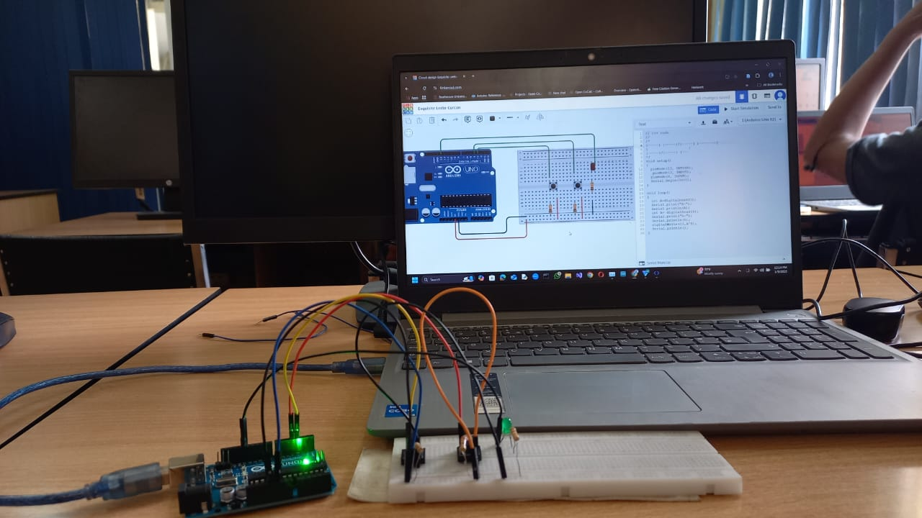
Figure 1. setup_1
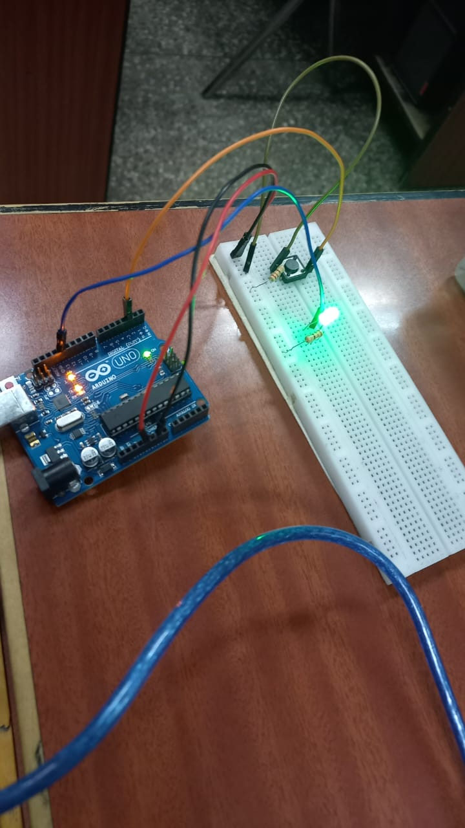
Figure 2. setup_2
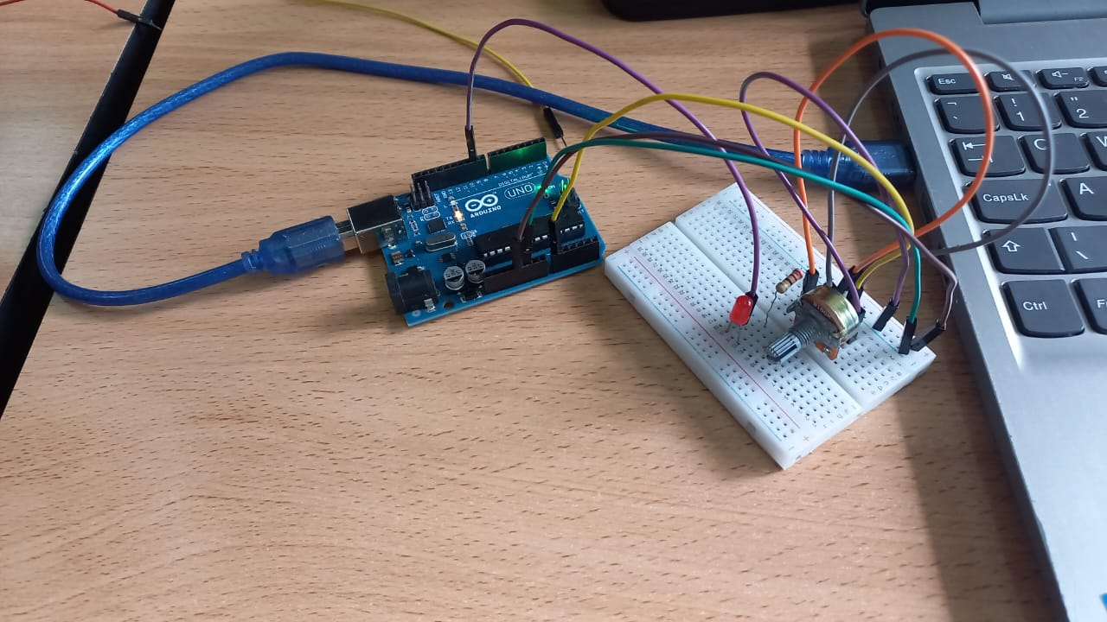
Figure 3. setup_3
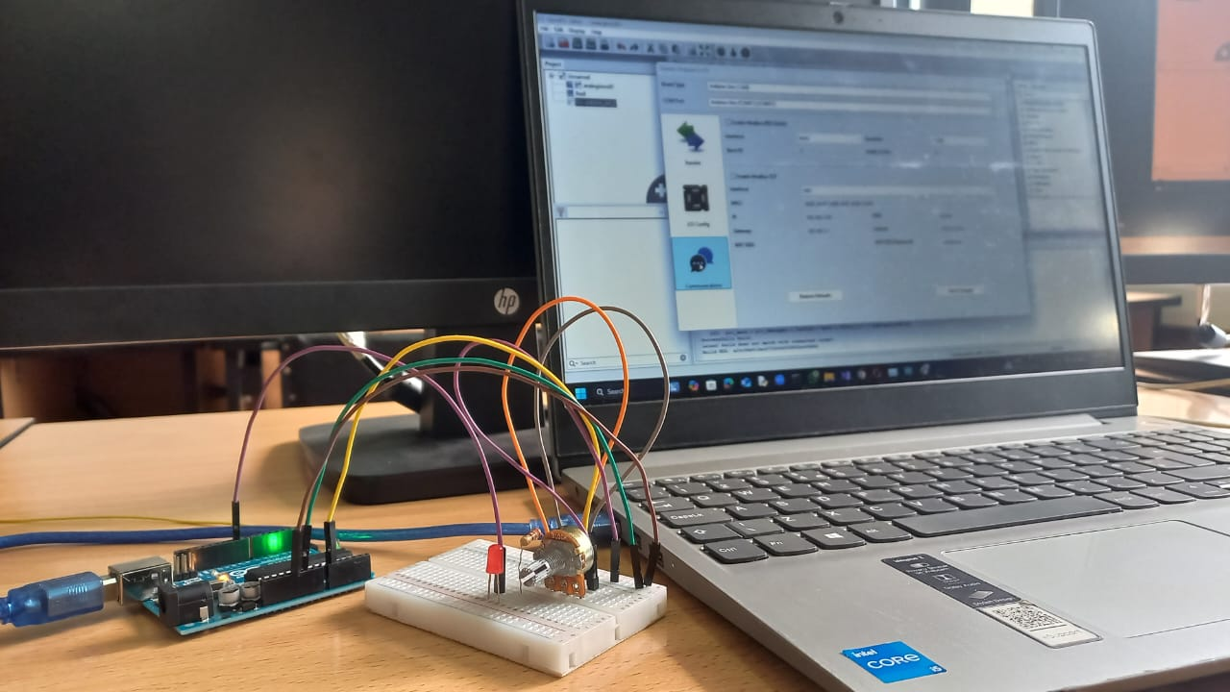
Figure 4. setup_4
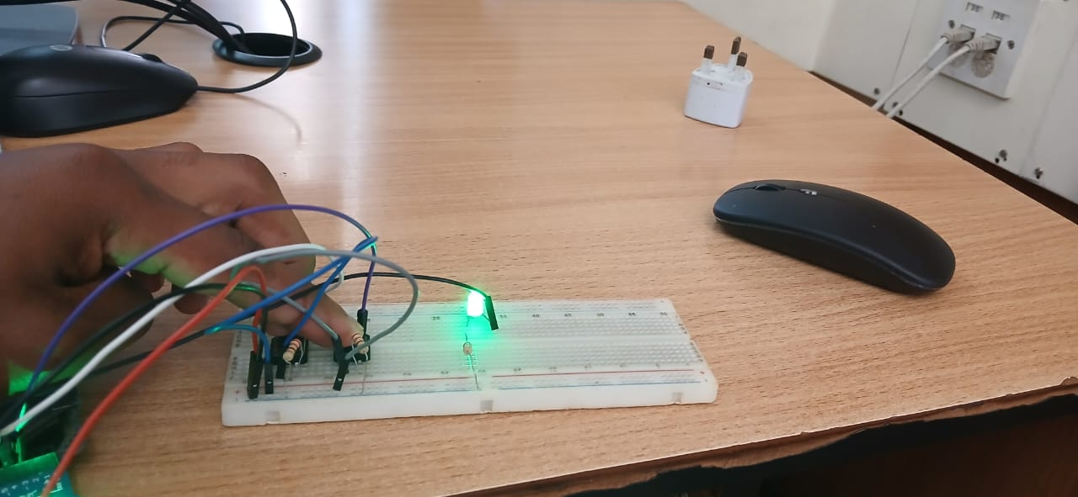
Figure 5. setup_5
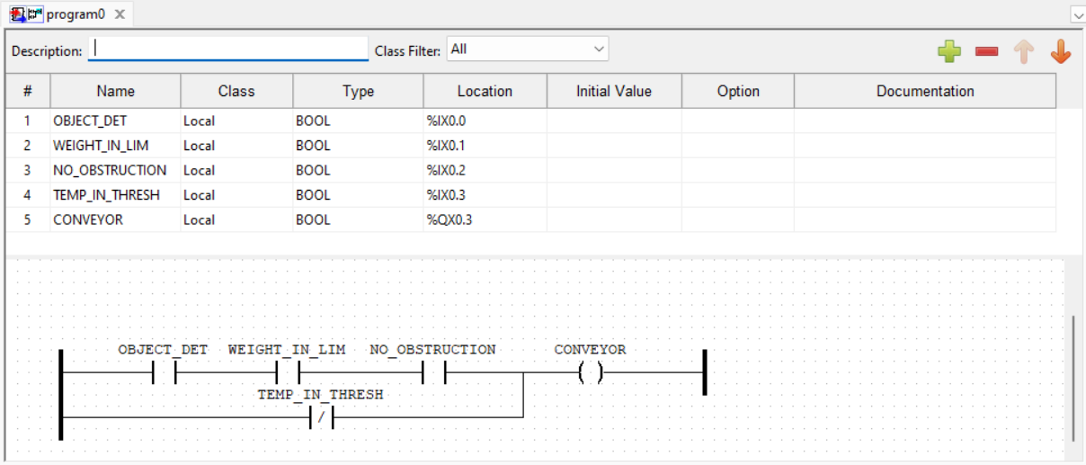
Figure 6. Conveyor system
void sketch_setup()
{
pinMode(13, OUTPUT);

pinMode(2, INPUT);

pinMode(3, INPUT);

pinMode(4, INPUT);

pinMode(5, INPUT);

Serial.begin(9600);
}

void sketch_loop()
{
int A= digitalRead(2);

Serial.print("A=");

Serial.println(A);

int B= digitalRead(3);

Serial.print("B=");

Serial.println(B);

int C= digitalRead(4);

Serial.print("C=");

Serial.println(C);

int D= digitalRead(5);

Serial.print("D=");

Serial.println(D);

digitalWrite(13,(A&B&C)|!D);

Serial.println();

}
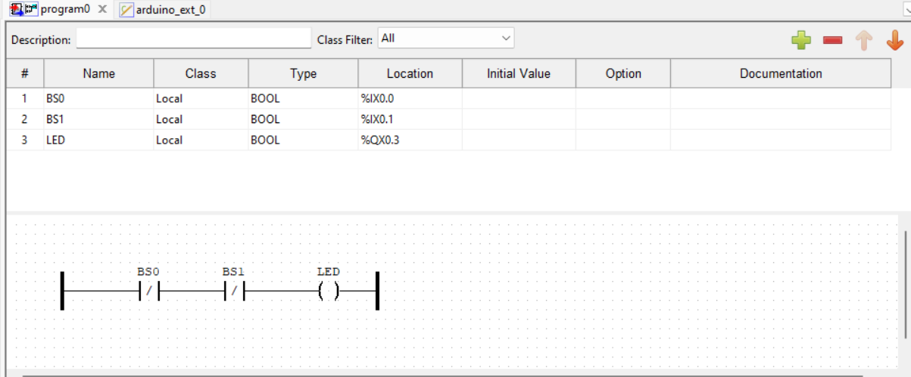
Figure 7. all gates implementation
void sketch_setup()
{
pinMode(13, OUTPUT);

pinMode(3, INPUT);

pinMode(4, INPUT);

Serial.begin(9600);
}

void sketch_loop()
{
int A=digitalRead(3);

Serial.print("A=");

Serial.println(A);

int B= digitalRead(4);

Serial.print("B=");

Serial.println(B);

//digitalWrite(13,A|B);//OR

//digitalWrite(13,A&B);//AND

//digitalWrite(13,!(A|B));//NOR

digitalWrite(13,!(A&B));//NAND

//digitalWrite(13,A^B);//XOR

//digitalWrite(13,!(A^B));XNOR

Serial.println();
}
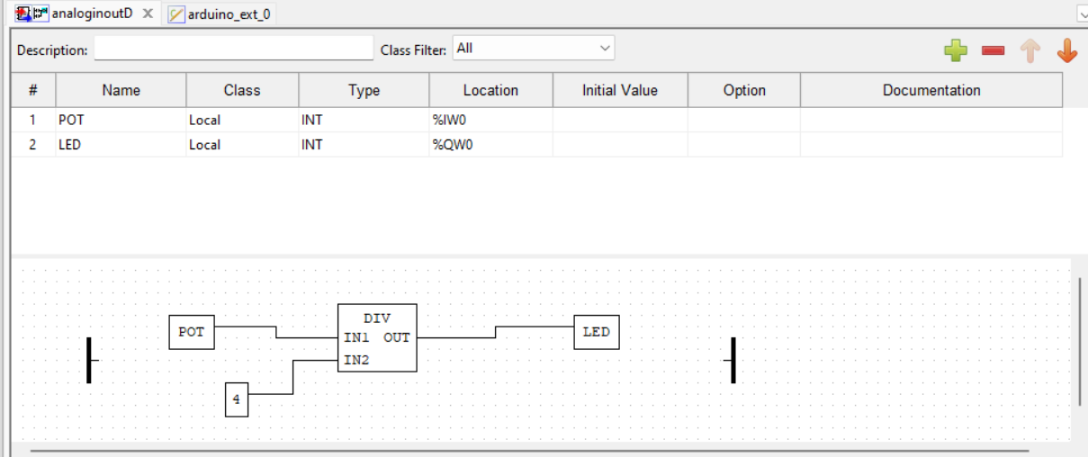
Figure 8. analoginout
void sketch_setup()
{

pinMode(9, OUTPUT);

pinMode(A0, INPUT);

Serial.begin(9600);

}

void sketch_loop()
{
int A=analogRead(A0);

Serial.print("A=");

Serial.println(A);

int B=map(A,0,1023,0,255);

Serial.print("B=");

Serial.println(B);

Serial.println();

analogWrite(9,B);
}
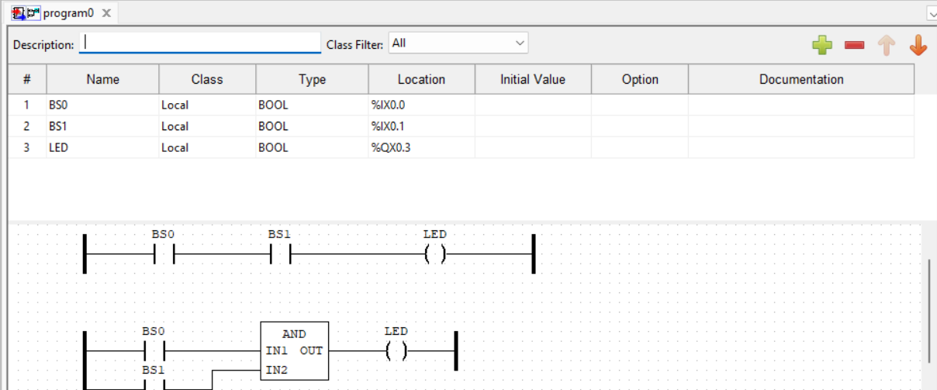
Figure 9. and gate implementation
void sketch_setup()
{
pinMode(13, OUTPUT);

pinMode(3, INPUT);

pinMode(4, INPUT);

Serial.begin(9600);
}

void sketch_loop()
{
int A=digitalRead(3);

Serial.print("A=");

Serial.println(A);

int B= digitalRead(4);

Serial.print("B=");

Serial.println(B);

digitalWrite(13,A&B);

Serial.println();
}
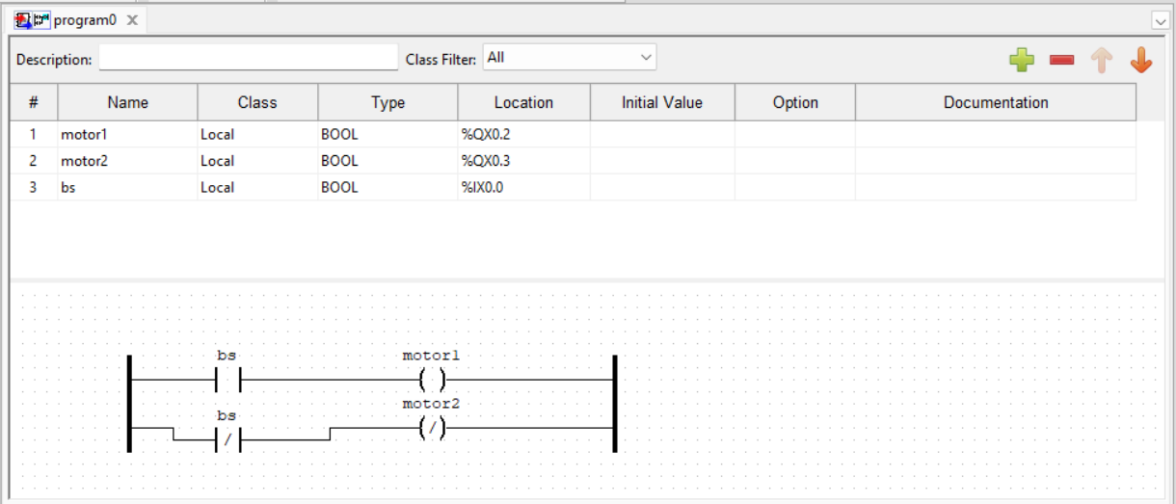
Figure 10. buttonMotor control
void sketch_setup()
{
Serial.begin(9600);

pinMode(2, INPUT);

pinMode(12, OUTPUT);

pinMode(13, OUTPUT);
}

void sketch_loop()
{
int A= digitalRead(2);

Serial.print("A=");

Serial.println(A);

//DIRECTION CHANGE

if(A==1){

digitalWrite(12,HIGH);

digitalWrite(13,LOW);

}

else if(A==0){

digitalWrite(12,LOW);

digitalWrite(13,HIGH);

}
}
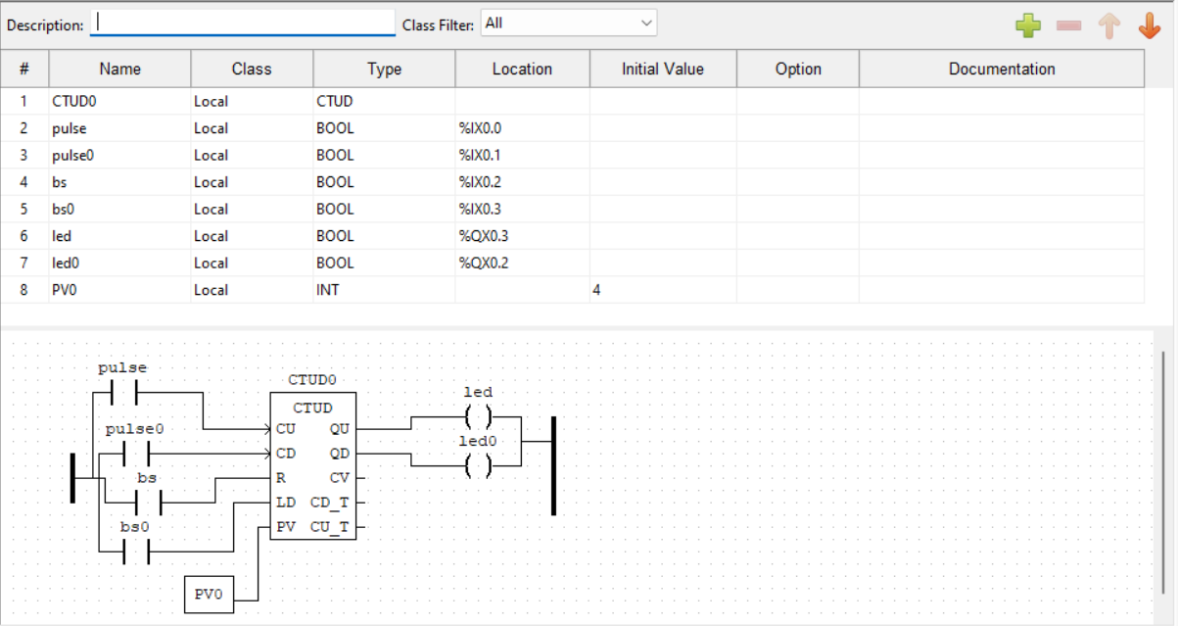
Figure 11. down counter
int counter = 4;

void sketch_setup()
{

pinMode(13, OUTPUT);

pinMode(2, INPUT);

pinMode(3, INPUT);

Serial.begin(9600);

}

void sketch_loop()
{
int PULSE=digitalRead(2);

Serial.print("PULSE = ");

Serial.println(PULSE);

int R = digitalRead(3);

Serial.print("R =");

Serial.println(R);

if(PULSE==1){

counter=counter-1;

delay(200);

Serial.print("counter = ");

Serial.println(counter);

}

if(counter==0){

digitalWrite(13, HIGH);

}

else{

digitalWrite(13, LOW);

}

if(R==1){

counter=4;

}

}
}
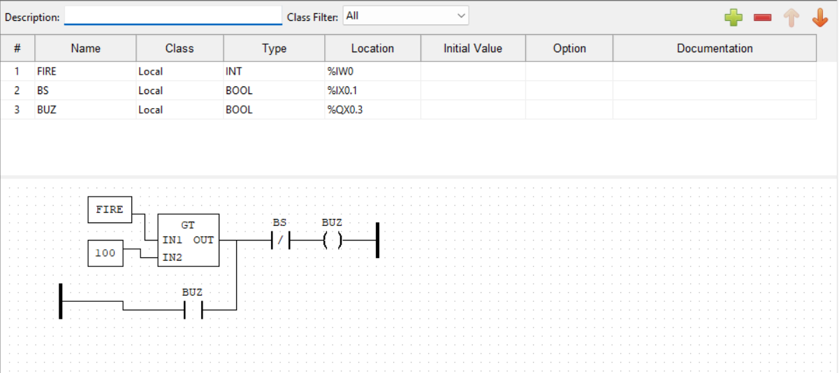
Figure 12. Fire alarm
int buzzerstate=0;

void sketch_setup()
{
pinMode(13, OUTPUT);

pinMode(2, INPUT);

pinMode(2, INPUT);

Serial.begin(9600);
}

void sketch_loop()
{
int A = digitalRead(2);

Serial.print("A =");

Serial.println(A);

int B = digitalRead(3);

Serial.print("B =");

Serial.println(B);

buzzerstate = (buzzerstate|A)&!B;

digitalWrite(13, buzzerstate);
}
-0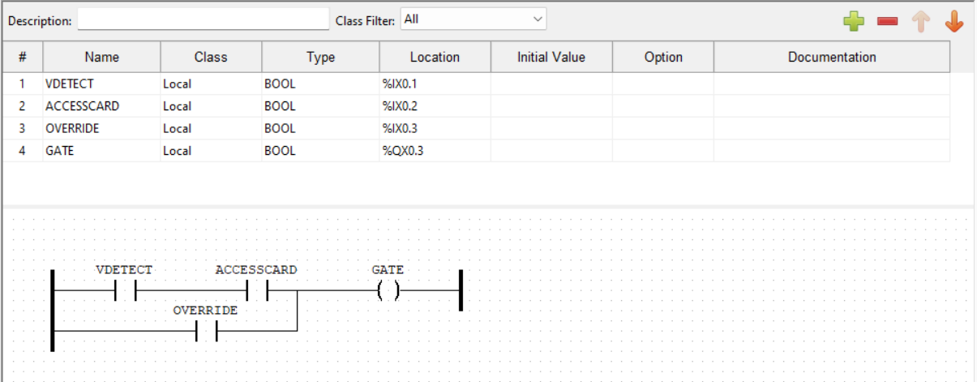
Figure 13. gate control system
void sketch_setup()
{
pinMode(13, OUTPUT);

pinMode(3, INPUT);

pinMode(4, INPUT);

pinMode(5, INPUT);

Serial.begin(9600);
}

void sketch_loop()
{
int A = digitalRead(3);

Serial.print("A=");

Serial.println(A);

int B = digitalRead(4);

Serial.print("B=");

Serial.println(B);

int C = digitalRead(5);

Serial.print("C=");

Serial.println(C);

digitalWrite(13,(A&B)|C)

serial.println();
}
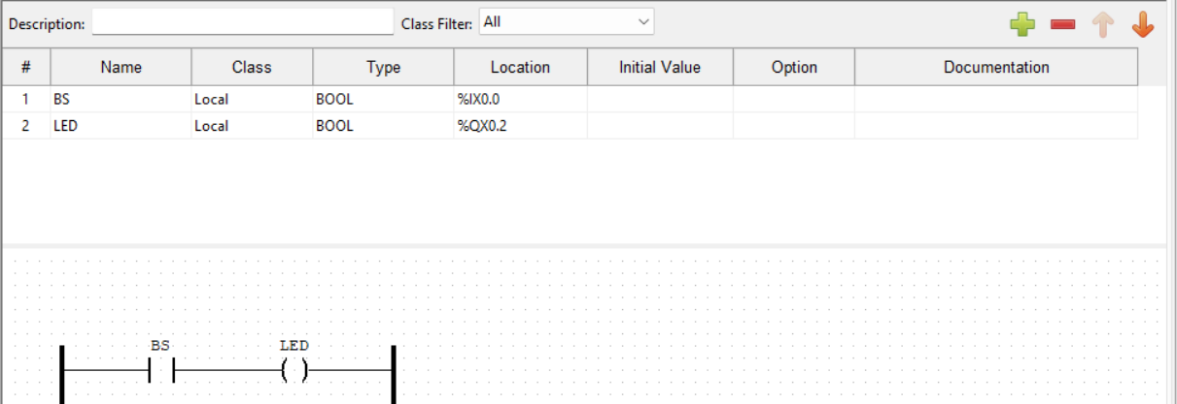
Figure 14. gate with serial input
void sketch_setup()
{
Serial.begin(9600);

pinMode(13, OUTPUT);
}

void sketch_loop()
{
if(Serial.available()>0){

int A= digitalRead(12);

Serial.print("A=");

Serial.println(A);

int B = Serial.parseInt();

Serial.print("B=");

Serial.println(B);

digitalWrite(13, A|B);

Serial.println();
}
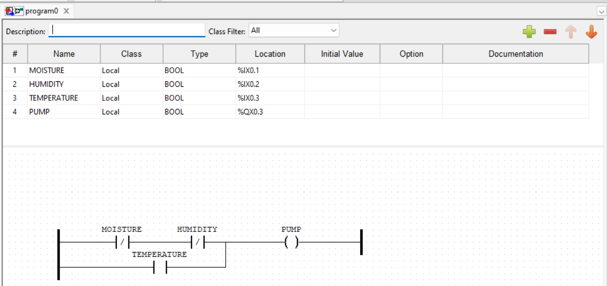
Figure 15. greenhouse sensors
void sketch_setup()
{
pinMode(13, OUTPUT);

pinMode(3, INPUT);

pinMode(4, INPUT);

pinMode(5, INPUT);

Serial.begin(9600);
}

void sketch_loop()
{
int A=digitalRead(3);

Serial.print("A=");

Serial.println(A);

int B=digitalRead(4);

Serial.print("B=");

Serial.println(B);

int C=digitalRead(5);

Serial.print("C=");

Serial.println(C);

digitalWrite(13,!A&!B|C);

Serial.println();
}
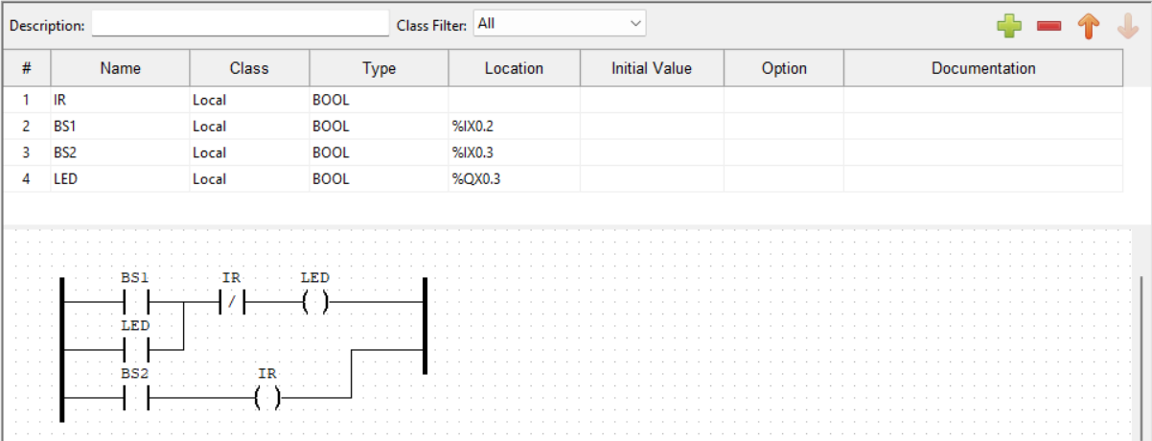
Figure 16. IR with LED
void setup()
{
pinMode(13, OUTPUT);
}
void loop()
{
digitalWrite(13, HIGH);
// digitalWrite(LED_BUILTIN, LOW);
}
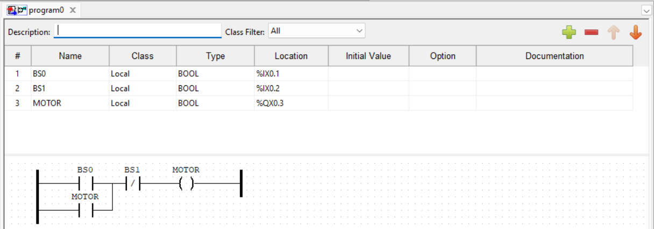
Figure 17. latch implementation
int motorstate = 0;

void sketch_setup()
{

pinMode(13, OUTPUT);

pinMode(3, INPUT);

pinMode(4, INPUT);

Serial.begin(9600);
}

void sketch_loop()
{
int A= digitalRead(3);

Serial.print("A=");

Serial.println(A);

int B= digitalRead(4);

Serial.print("B=");

Serial.println(B);

/ if (A==1){

digitalWrite(13, HIGH);

}

if(B==1){

digitalWrite(13, LOW);

}/

motorstate= (A|motorstate)&!B;

Serial.print("motor state = ");

Serial.println(digitalRead(13));

Serial.println();

delay(100);
}
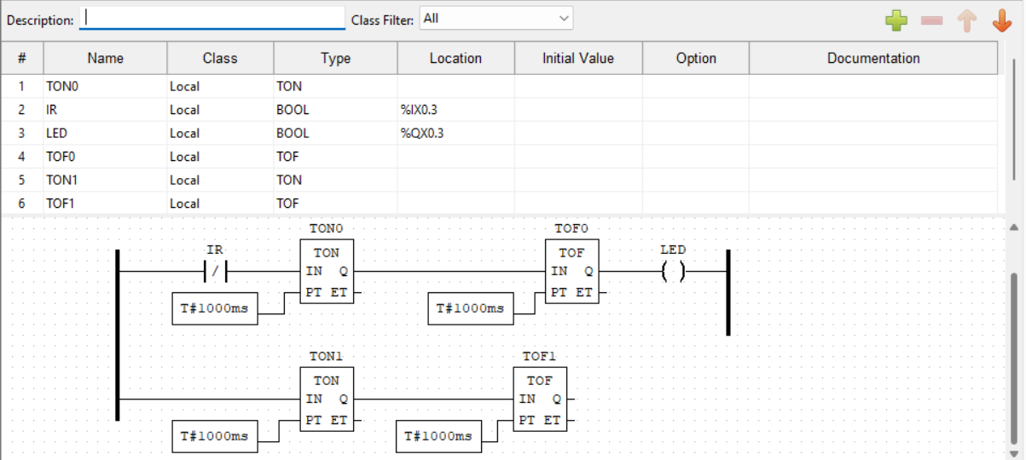
Figure 18. latching with an IR
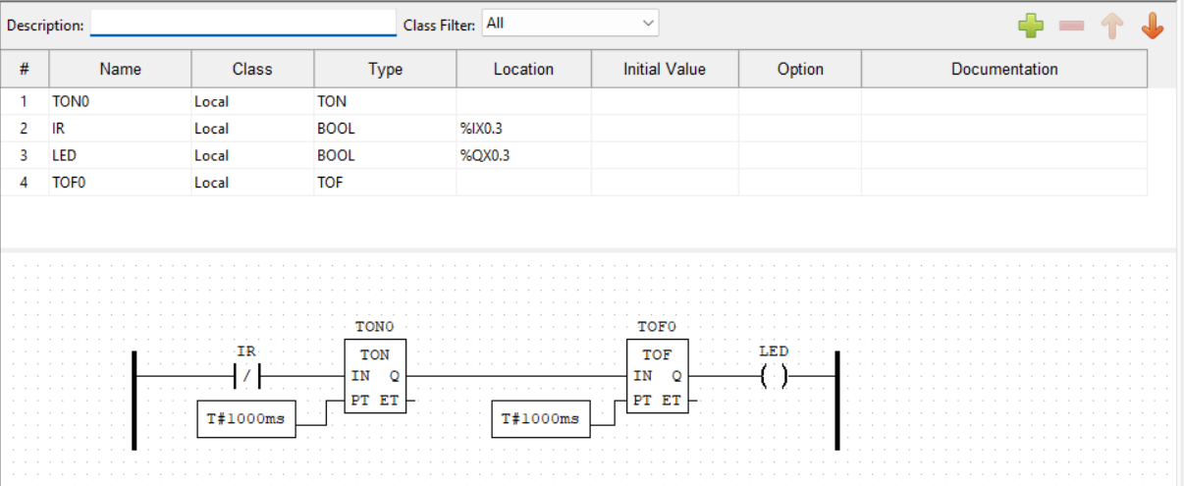
Figure 19. LED blink
void sketch_setup()
{
pinMode(3, OUTPUT);
}

void sketch_loop()
{
digitalWrite(3, HIGH);
delay(1000);
digitalWrite(3, LOW);
delay(1000);
}
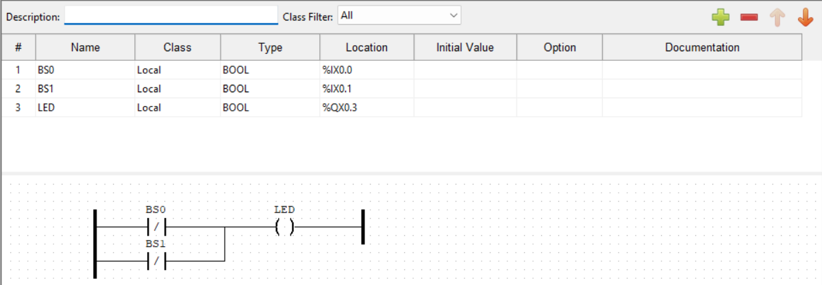
Figure 20. NAND Gate implementation
void sketch_setup()
{
pinMode(13, OUTPUT);

pinMode(3, INPUT);

pinMode(4, INPUT);

Serial.begin(9600);
}

void sketch_loop()
{
int A=digitalRead(3);

Serial.print("A=");

Serial.println(A);

int B= digitalRead(4);

Serial.print("B=");

Serial.println(B);

digitalWrite(13,!(A&B));

Serial.println();
}
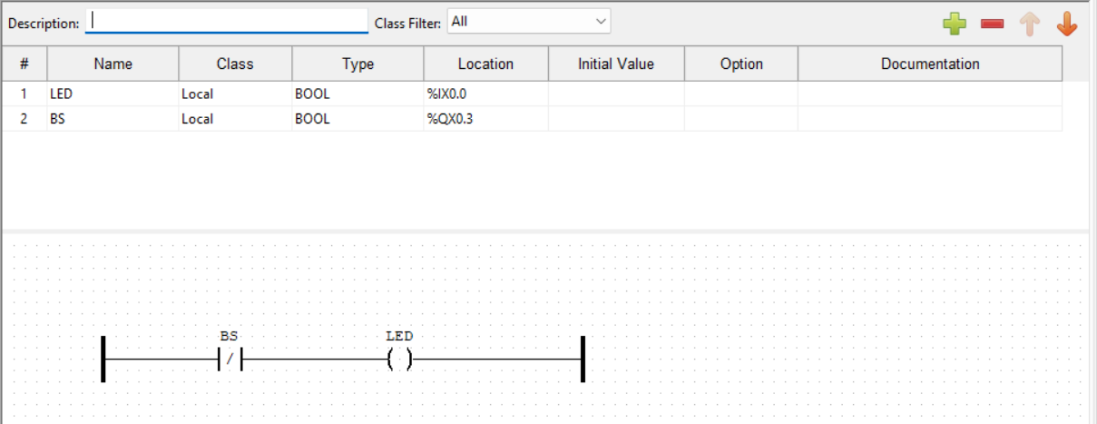
Figure 21. not gate implementation
void sketch_setup()
{
pinMode(13, OUTPUT);

pinMode(2, INPUT);

Serial.begin(9600);
}

void sketch_loop()
{
int A=digitalRead(3);

Serial.println("A=");

Serial.println(A);

digitalWrite(2,!A);
}
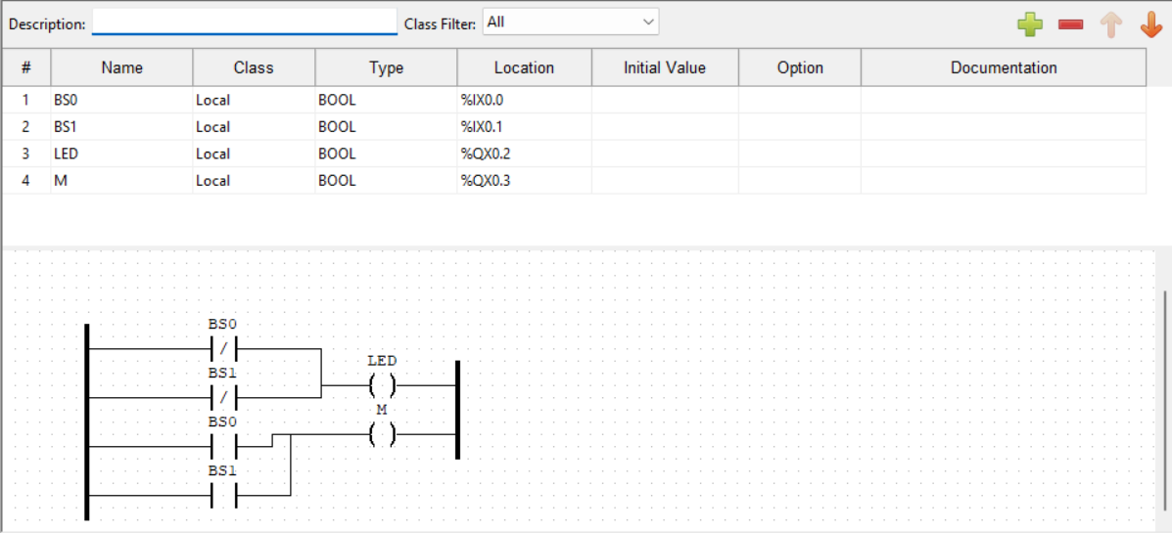
Figure 22. OR NAND gate
void sketch_setup()
{
pinMode(12, OUTPUT);

pinMode(13, OUTPUT);

pinMode(2, INPUT);

pinMode(3, INPUT);

Serial.begin(9600);
}

void sketch_loop()
{
int A = digitalRead(2);

Serial.print("A=");

Serial.println(A);

int B = digitalRead(3);

Serial.print("B=");

Serial.println(B);

digitalWrite(12, !(A&B));

digitalWrite(13, A|B);

Serial.println();
}
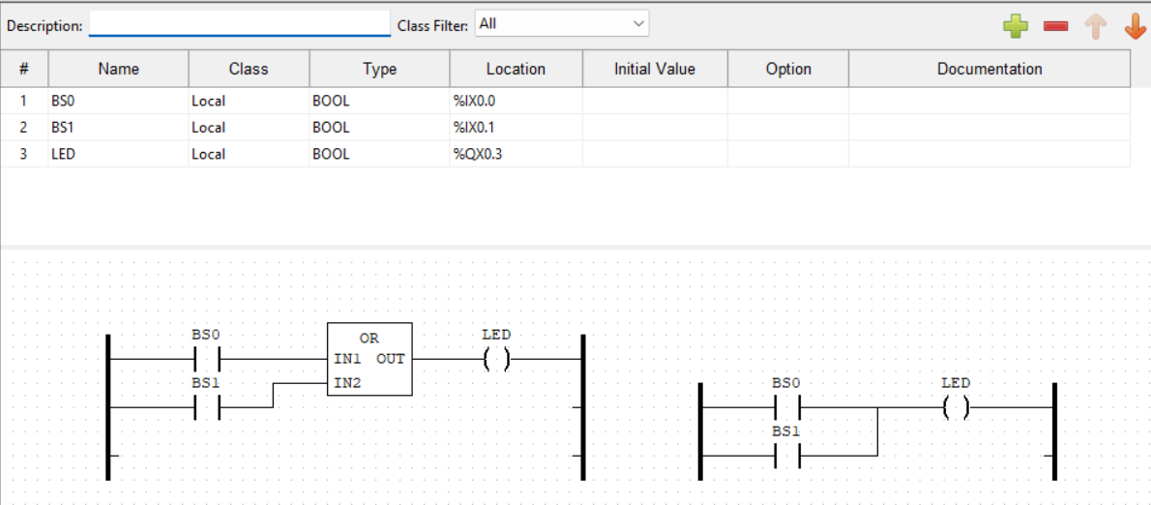
Figure 23. OR Gate
void sketch_setup()
{
pinMode(13, OUTPUT);

pinMode(3, INPUT);

pinMode(4, INPUT);

Serial.begin(9600);
}

void sketch_loop()
{
int A=digitalRead(3);

Serial.print("A=");

Serial.println(A);

int B= digitalRead(4);

Serial.print("B=");

Serial.println(B);

digitalWrite(13,A|B);

Serial.println();
}
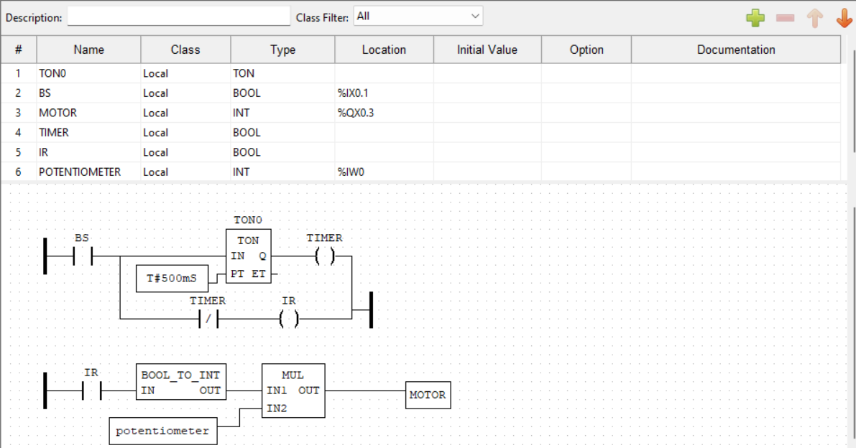
Figure 24. PTWIA implementation
void sketch_setup()
{
pinMode(13, OUTPUT);

pinMode(3, INPUT);

Serial.begin(9600);
}

void sketch_loop()
{
int A = digitalRead(3);

Serial.print("A = ");

Serial.println(A);

digitalWrite(13, A);

delay(2000);

digitalWrite(13, LOW);

delay(2000);

Serial.println();
}
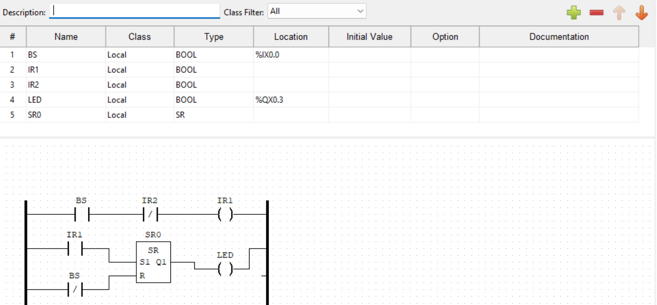
Figure 25. pulse function
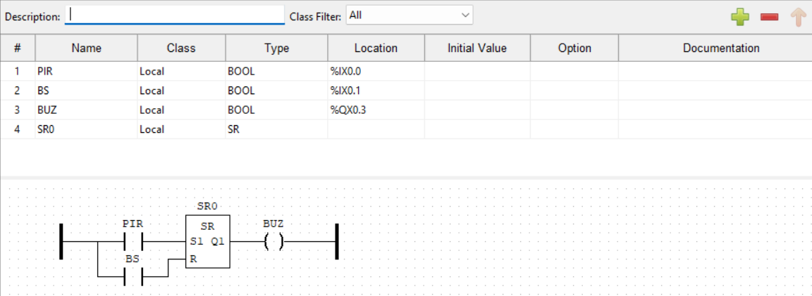
Figure 26. security SR
int buzzerstate=0;

void sketch_setup()
{
pinMode(13, OUTPUT);

pinMode(2, INPUT);

pinMode(2, INPUT);

Serial.begin(9600);
}

void sketch_loop()
{
int A = digitalRead(2);

Serial.print("A =");

Serial.println(A);

int B = digitalRead(3);

Serial.print("B =");

Serial.println(B);

buzzerstate = (buzzerstate|A)&!B;

digitalWrite(13, buzzerstate);
}
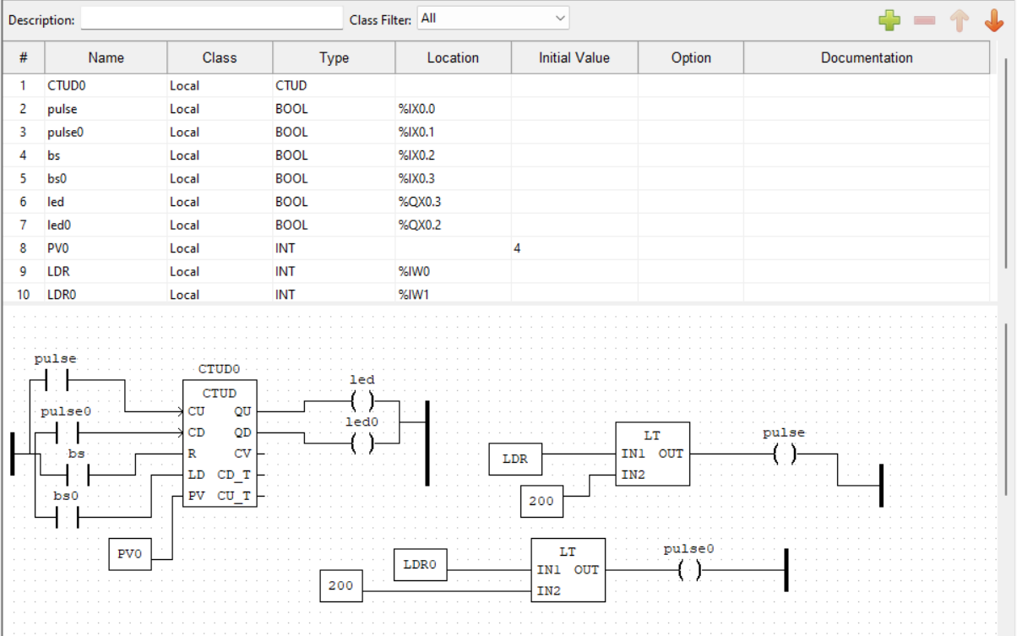
Figure 27. simple car parking system
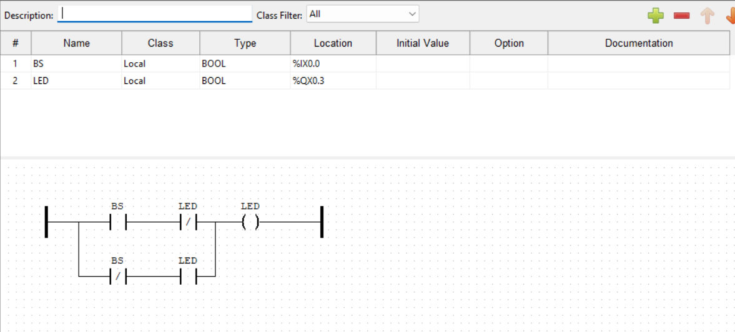
Figure 28. toggle flipflop
bool motorstate = 0;

void sketch_setup()
{
pinMode(13, OUTPUT);

pinMode(2, INPUT);

Serial.begin(9600);
}

void sketch_loop()
{
bool A = digitalRead(2);

Serial.print("A = ");

Serial.println(A);

motorstate = motorstate^A;

Serial.print("motorstate = ");

Serial.println(motorstate);

digitalWrite(13, motorstate);

Serial.println();

delay(200);
}
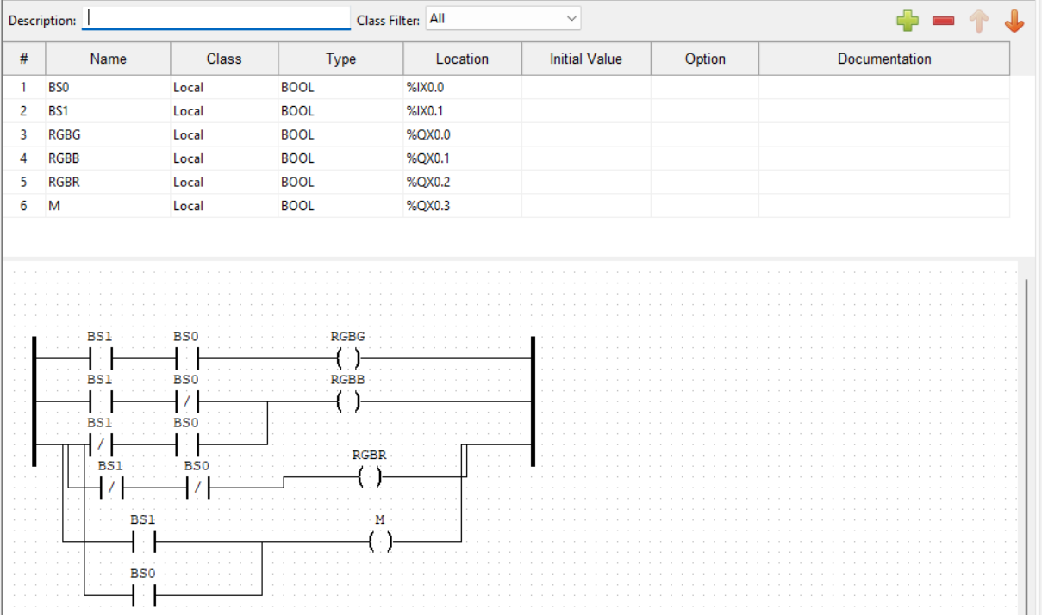
Figure 29. two in rgb motor
void sketch_setup()
{
pinMode(2, INPUT);

pinMode(3, INPUT);

pinMode(10, OUTPUT);

pinMode(11, OUTPUT);

pinMode(12, OUTPUT);

pinMode(13, OUTPUT);

Serial.begin(9600);
}

void sketch_loop()
{
int A = digitalRead(2);

Serial.print("A =");

Serial.println(A);

int B = digitalRead(3);

Serial.print("B =");

Serial.println(B);

digitalWrite(10,A&B);

digitalWrite(11,A^B);

digitalWrite(12,!(A&B));

digitalWrite(13,A|B));

Serial.println();
}
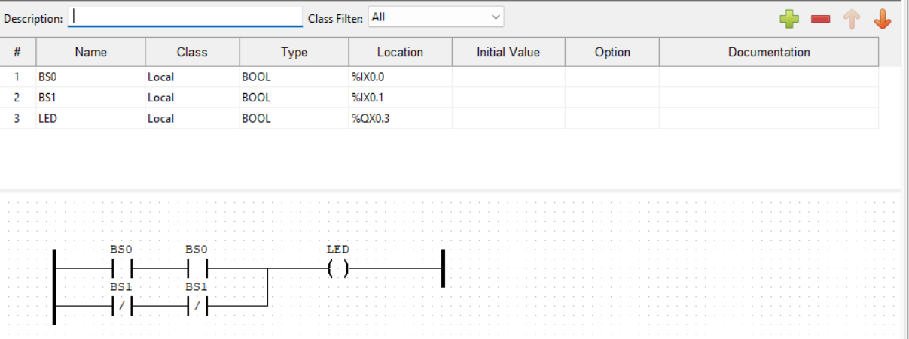
Figure 30. xnor gate
void setup()
{
pinMode(13, OUTPUT);
pinMode(3, INPUT);
pinMode(4, INPUT);
Serial.begin(9600);
}

void loop()
{
int A=digitalRead(3);
Serial.print("A=");
Serial.println(A);
int B= digitalRead(4);
Serial.print("B=");
Serial.println(B);
digitalWrite(!(13,A^B));
Serial.println();
}
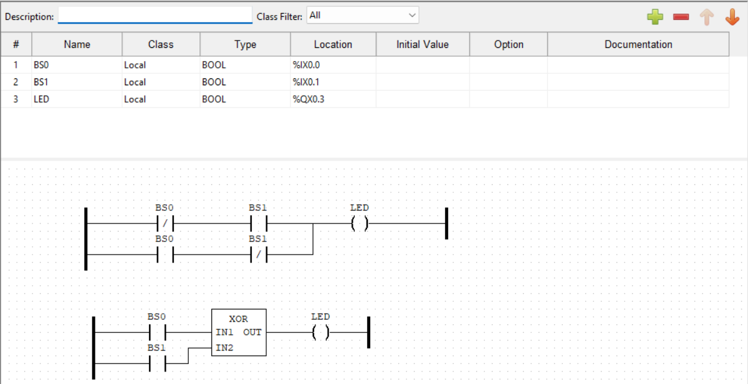
Figure 31. XOR gate implementation
void sketch_setup()
{
pinMode(13, OUTPUT);

pinMode(3, INPUT);

pinMode(4, INPUT);

Serial.begin(9600);
}

void sketch_loop()
{
int A=digitalRead(3);

Serial.print("A=");

Serial.println(A);

int B= digitalRead(4);

Serial.print("B=");

Serial.println(B);

digitalWrite(13,A^B);

Serial.println();
}

Results and discussion
1. Conveyor System (Figure 1):
- Code: The code reads inputs from four sensors and controls an output based on the logical condition ‘(A & B & C) |! D’.
- Result: The conveyor belt system successfully responded to the input conditions, demonstrating the ability to control industrial processes using PLC logic.
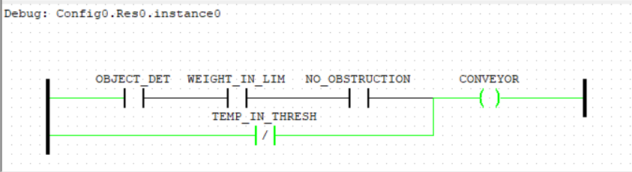
Figure 32. conveyor belt result 1
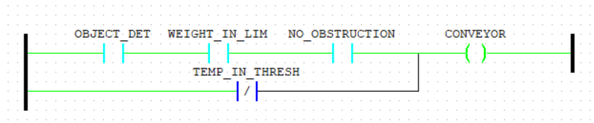
Figure 33. conveyor belt result 2
2. All Gates Implementation (Figure 2):
Code: The code implements various logic gates (AND, OR, NAND, NOR, XOR, XNOR) using digital inputs and outputs.
Result: The output LEDs correctly reflected the logical operations, validating the implementation of basic logic functions.
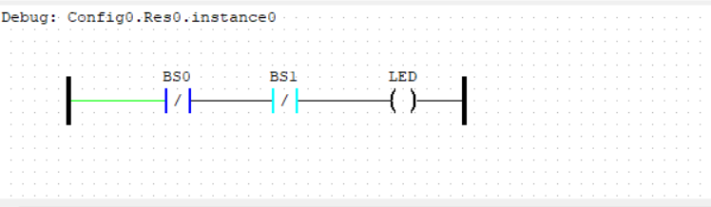
Figure 34. all gates result

3. Analog In-Out (Figure 3):
- Code: The code reads an analog input from a potentiometer and maps it to control the brightness of an LED.
- Result: The LED brightness varied smoothly with the potentiometer input, demonstrating analog signal processing.

4. AND Gate Implementation (Figure 4):
- Code: The code implements an AND gate using two digital inputs and one output.
- Result: The output LED turned on only when both inputs were high, confirming the correct operation of the AND gate.
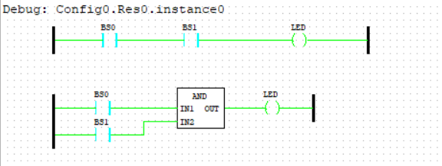
Figure 35. and gate result
5. Button Motor Control (Figure 5):
- Code: The code controls the direction of a DC motor based on a button input.
- Result: The motor changed direction as expected when the button was pressed, demonstrating simple motor control.
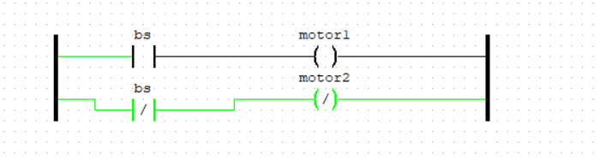
Figure 36. buttonMotor control result
6. Down Counter (Figure 6):
- Code: The code implements a down counter that decrements with each pulse input and resets with a reset input.
- Result: The counter successfully decremented and reset, showing the ability to implement counting functions.

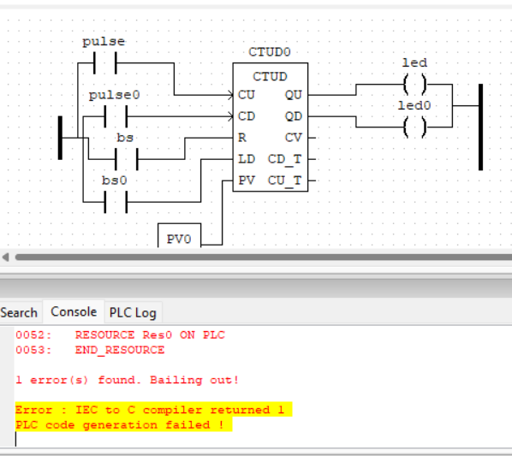
Figure 37. down counter result
7. Fire Alarm (Figure 7):
- Code: The code simulates a fire alarm system using a buzzer and two inputs (smoke and reset).
- Result: The buzzer activated when the smoke input was high and deactivated with the reset input, demonstrating a basic alarm system.
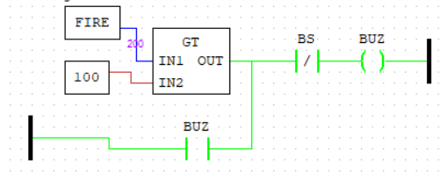
8. Gate Control System (Figure 8):
- Code: The code controls a gate based on three inputs using the logical condition `(A & B) | C`.
- Result: The gate opened and closed as expected, validating the control logic.
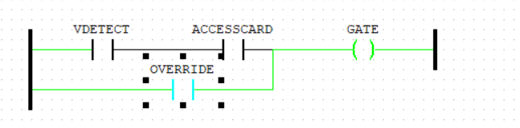
Figure 38. gate control system result
9. Gate with Serial Input (Figure 9):
- Code: The code reads a serial input and uses it to control an output based on a logical OR operation.
- Result: The output responded correctly to the serial input, demonstrating serial communication in PLC systems.

Figure 39. gate with serial input result
10. Greenhouse Sensors (Figure 10):
- Code: The code reads inputs from three sensors (temperature, humidity, and light) and controls an output based on the condition `!A & !B | C`.
- Result: The output correctly reflected the sensor inputs, showing the ability to automate environmental control systems.
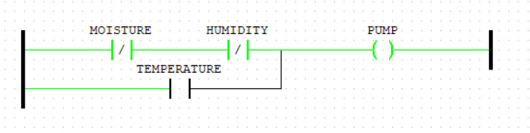
Figure 40. greenhouse sensor result
11. IR with LED (Figure 11):
- Code: The code uses an IR sensor to control an LED.
- Result: The LED turned on when the BS1 was pressed and remained on when it was not pressed. The LED turned off when BS2 was pressed.
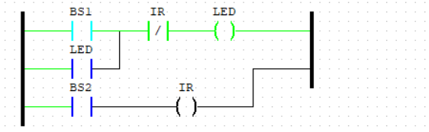
Figure 41.IR with LED
12. Latch Implementation (Figure 12):
- Code: The code implements a latch using two inputs (set and reset) and one output.
- Result: The output maintained its state after the set input was activated, demonstrating latching behavior.
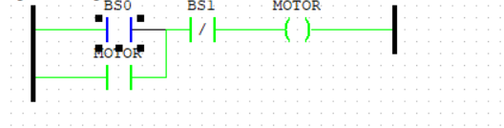
Figure 42. latch results
13. Latching with an IR (Figure 13):
- Code: The code combines an IR sensor with a latch to control output.
- Result: The output maintained its state based on the IR sensor input, showing the integration of sensors with latching logic.
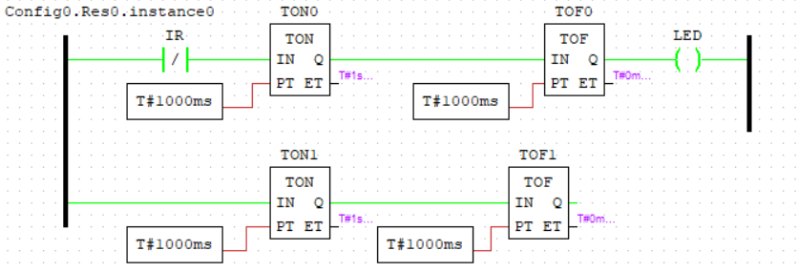
Figure 43. latching with IR results
14. LED Blink (Figure 14):
- Code: The code blinks an LED at a 1-second interval.
- Result: The LED blinked as expected, demonstrating basic timing control.
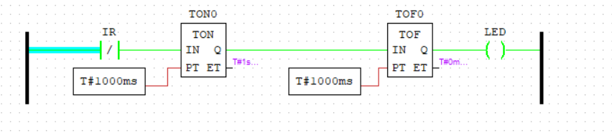
Figure 44.LED blink results
15. NAND Gate Implementation (Figure 15):
- Code: The code implements a NAND gate using two digital inputs and one output.
- Result: The output LED turned off only when both inputs were high, confirming the correct operation of the NAND gate.
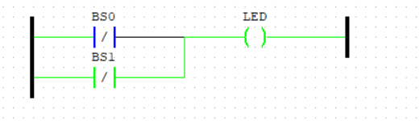
Figure 45. NAND gate implementation
16. NOT Gate Implementation (Figure 16):
- Code: The code implements a NOT gate using one digital input and one output.
- Result: The output LED turned on when the input was low and vice versa, validating the NOT gate operation.

Figure 46. NOT gate result
17. OR NAND Gate (Figure 17):
- Code: The code implements both OR and NAND gates using two inputs and two outputs.
- Result: The outputs correctly reflected the OR and NAND operations, demonstrating multiple logic functions.
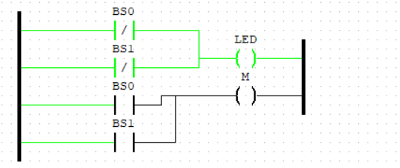
Figure 47. OR NAND gate result
18. OR Gate (Figure 18):
- Code: The code implements an OR gate using two digital inputs and one output.
- Result: The output LED turned on when either input was high, confirming the correct operation of the OR gate.
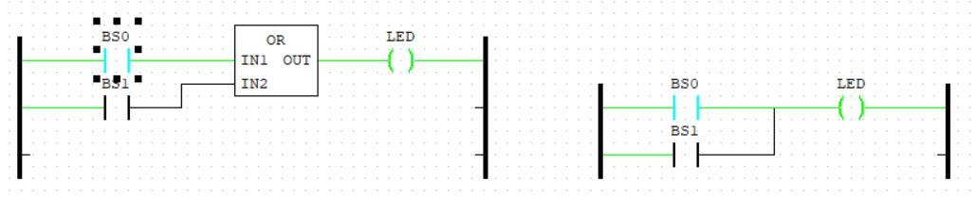
Figure 48. OR gate results
19. PTWIA Implementation (Figure 19):
- Code: The code implements pulse-width modulation (PWM) based on an input signal.
- Result: The output varied based on the input signal, demonstrating PWM control.
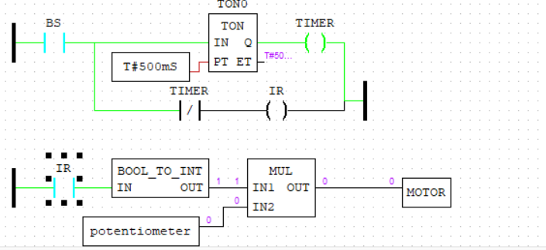
Figure 49. PTWIA result
20. Pulse Function (Figure 20):
- Code: The code generates a pulse signal based on an input.
- Result: The output generated a pulse as expected, showing the ability to create timing signals.
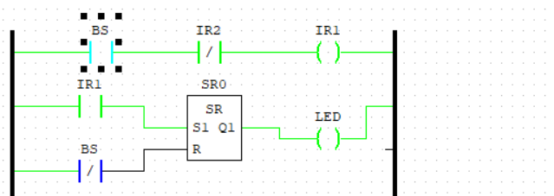
Figure 50. pulse function result
21. Security SR (Figure 21):
- Code: The code implements a security system using a set-reset (SR) latch.
- Result: The output maintained its state based on the set and reset inputs, demonstrating a basic security system.
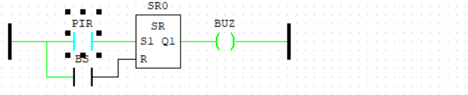
Figure 51. Security SR result
22. Simple Car Parking System (Figure 22):
- Code: The code simulates a car parking system using sensors and an output indicator.
- Result: The output indicated the presence of a car, demonstrating a simple parking system.
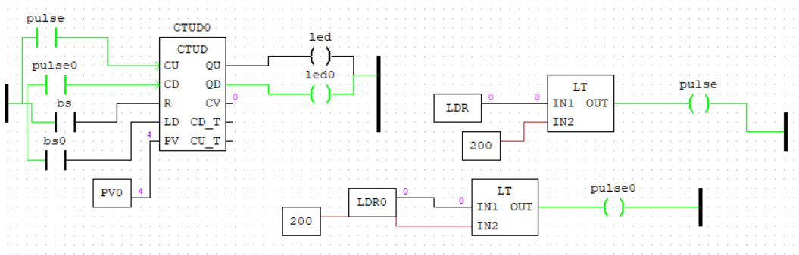
Figure 52. simple car parking system
23. Toggle Flip-Flop (Figure 23):
- Code: The code implements a toggle flip-flop using one input and one output.
- Result: The output toggled its state with each input pulse, demonstrating flip-flop behavior.
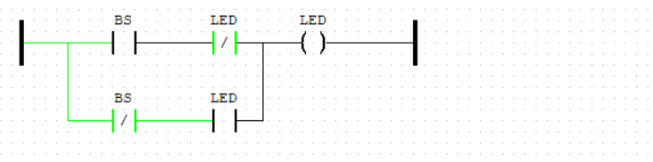
Figure 53. toggle flipflop results
24. Two in RGB Motor (Figure 24):
- Code: The code controls an RGB LED, and a motor based on two inputs.
- Result: The RGB LED and motor responded correctly to the inputs, showing the ability to control multiple devices.
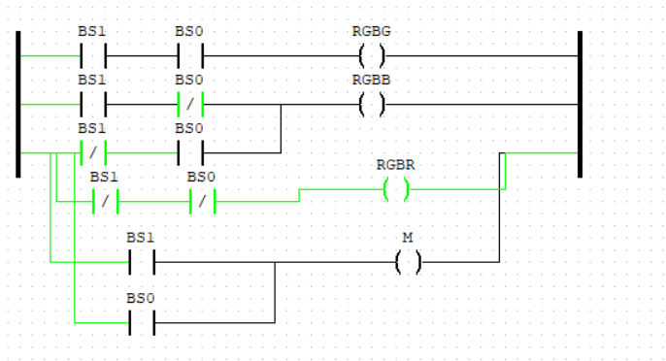
Figure 54. two in rgb motor results
25. XNOR Gate (Figure 25):
- Code: The code implements an XNOR gate using two digital inputs and one output.
- Result: The output LED turned on when both inputs were the same, confirming the correct operation of the XNOR gate.
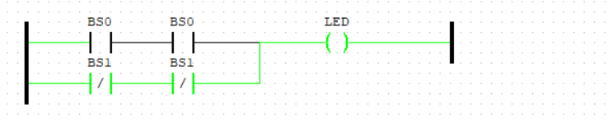
Figure 55. XNOR gate results
26. XOR Gate Implementation (Figure 26):
- Code: The code implements an XOR gate using two digital inputs and one output.
- Result: The output LED turned on when the inputs were different, validating the XOR gate operation.
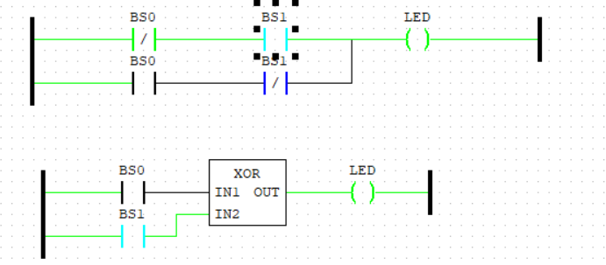
Figure 56. XOR gate results

Conclusions and recommendations
The experiments are closely related to the subject of PLC and Industrial Automation, which focuses on the design, implementation, and control of automated systems using programmable logic controllers. The hands-on experience gained from these experiments bridges the gap between theoretical concepts and practical applications, providing a deeper understanding of how PLCs are used in real-world industrial scenarios.
The experiments conducted in this lab report involved various PLC-based automation systems implemented using OpenPLC software and Arduino. The results were consistent with the expected outcomes, demonstrating the successful application of PLC logic in controlling industrial processes.

Key Findings
- Logic Gates Implementation: All basic logic gates (AND, OR, NOT, NAND, NOR, XOR, XNOR) were successfully implemented, with the output LEDs correctly reflecting the logical operations.
- Timers and Counters: The down counter experiment showed accurate decrementing and reset functionality, while the pulse function experiment demonstrated precise timing control.
- Motor Control: The button motor control experiment successfully changed the direction of the motor based on the input, and the two-in RGB motor experiment controlled both an RGB LED and a motor simultaneously.
- Sensor Integration: Experiments involving sensors (e.g., IR sensor, greenhouse sensors) demonstrated the ability to integrate sensors into automation systems for real-time monitoring and control.
- Analog Signal Processing: The analog in-out experiment showed smooth control of LED brightness based on analog input, demonstrating the ability to process analog signals in PLC systems.

Key Learnings
- PLC Programming: The experiments provided hands-on experience with PLC programming using ladder logic and structured text, which are widely used in industrial automation.
- Sensor Integration: The ability to integrate sensors (e.g., IR, temperature, light) into automation systems is crucial for real-world applications such as environmental monitoring, security systems, and process control.
- Motor Control: The experiments demonstrated basic motor control techniques, which are essential in applications like conveyor systems, robotics, and automated machinery.
- Logic Functions: The implementation of logic gates and sequential logic (e.g., latches, flip-flops) is fundamental in designing control systems for industrial processes.

Real-Life Applications
These learnings are directly applicable to real-life situations, such as:
- Manufacturing: Controlling robotic arms, conveyor belts, and assembly lines.
- Energy Management: Optimizing power distribution and building energy systems.
- Transportation: Managing traffic signals, railway signaling, and airport baggage handling.
- Healthcare: Automating medical devices and HVAC systems in hospitals.

Possible Errors and Challenges
- Hardware Limitations: some of the equipment was faulty and a bit difficult to handle, which restricted the complexity of some experiments.
- Debugging: Identifying and fixing errors in the ladder logic and code required careful analysis and testing.
- Sensor Calibration: In experiments involving sensors (e.g., temperature, IR), calibration was necessary to ensure accurate readings. Improper calibration could lead to incorrect outputs.

Recommendations for Future Work
- Advanced PLC Hardware: Future experiments could involve more advanced PLC hardware with greater input/output capabilities and support for industrial communication protocols (e.g., Modbus, Profibus).
- Complex Automation Systems: Implementing more complex automation systems, such as multi-axis robotic arms, automated storage and retrieval systems (AS/RS), and smart grid systems, would provide valuable insights into advanced industrial automation.
- Integration with IoT: Exploring the integration of PLC systems with IoT (Internet of Things) for remote monitoring and control could open up new possibilities in industrial automation.
- Real-World Applications: Applying the concepts learned in this lab to real-world industrial projects, such as optimizing manufacturing processes or automating building energy management systems, would provide practical experience and demonstrate the impact of PLC technology.

In conclusion, the experiments successfully demonstrated the application of PLC programming in various automation scenarios, providing valuable insights into the design and implementation of industrial control systems. The skills and knowledge gained from these experiments are directly applicable to real-world industrial automation, and future work could explore more advanced applications and integrations.

References
OMAE OTERI ©2020 BOOKS -The Signals and Things in IoT & The Arduino E-kit available in OD
[1] “Docs – Autonomy.” Accessed: Mar. 21, 2025. [Online]. Available: https://autonomylogic.com/docs/
[2] “Learn how to use Tinkercad,” Tinkercad. Accessed: Mar. 21, 2025. [Online]. Available: https://www.tinkercad.com/learn/circuits
[3] “Tutorials | Arduino Documentation.” Accessed: Mar. 21, 2025. [Online]. Available: https://docs.arduino.cc/tutorials/

